Solvation Structure of Manganese(II) Ion in Water-N,N-Dimethylformamide
原則２ページ以上６ページまで
フォントはTimes New Roman
著者名：
12ポイント－中央
（太文字）
表題：
12ポイント－中央
（太文字）

and Water-1,1,3,3-Tetramethylurea Mixed Solvents
12ポイントで１行 あける
Misaki Katayama¹, Daisuke Tomita², Yuki Kajiya², Kenta Uoya²,
and Kazuhiko Ozutsumi²
- Research Organization of Science & Engineering, Ritsumeikan University, 1-1-1 Noji-Higashi, Kusatsu 525-8577, Japan
- Department of Applied Chemistry, Faculty of Life Sciences, Ritsumeikan University, 1-1-1 Noji-Higashi, Kusatsu 525-8577, Japan
所属：12ポイント－（斜体）
12ポイントで１行 あける

The solvation structure of manganese(II) ion in water-N,N-dimethylformamide (DMF) and water-1,1,3,3-tetramethylurea (TMU) solvent mixtures has been studied by the extended X-ray absorption fine structure (EXAFS) method. It has been revealed that manganese(II) ion has a six-coordinate structure with the Mn-O length of 217(2) pm in water-DMF mixed solvents. In neat TMU, the coordination number of Mn(II) ion is five and the Mn-O length is 210(1) pm due to the bulkiness of a TMU molecule. Therefore, it is expected that the coordination number decreases from 6 to 5 with increasing TMU contents in water-TMU mixed solvents. Result of the EXAFS analysis indicates that the decrease of the coordination number with increasing mole fractions of TMU corresponds to the shortening of the Mn-O distance.
Abstract：
10ポイント

- Introduction
In two component solvent mixtures, an ion is solvated with two different kinds of solvent molecules. The solvent composition in the first coordination sphere of the ion may usually not be the same as that in the bulk. Such preferential solvation phenomena affect t
本文：A4・縦長・横書き
カメラレディー方式
10ポイント

………………..

- Experimental
Preparation of Sample Solutions
Manganese(II) perchlorate hydrate was prepared by dissolving the manganese carbonate in dilute perchloric acid and then recrystallized from water. Manganese(II) perchlorate ……………..

- Results and Discussion
The extracted EXAFS oscillations of Mn(II) in the water-DMF solvents are shown in Fig. 1. The phase and amplitude of each curve are similar, although the shape at k = 3 to 6 ….

Table 1 Structural parameters for Mn(II) in water-DMF mixturesª
 | n | r / pm | σ² / 10 pm²
Water | 6^{b} | 217(1) | 6(1)
X_{DMF} = 0.1 | 5.9(0.4) | 216(1) | 6(1)
0.9 | 5.9(0.5) | 216(1) | 6(1)
DMF | 5.7(0.4) | 216(1) | 6(1)
ª The standard deviations are given in parentheses.
^{b}The value was kept constant during the least-squares calculations.

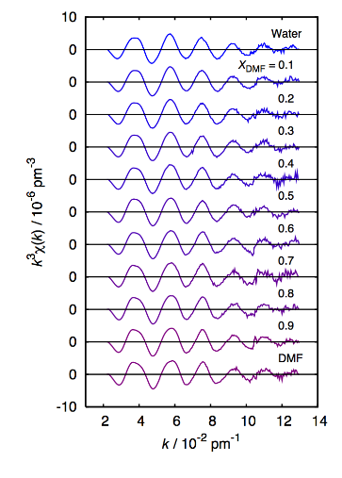

Fig. 1 The extracted EXAFS oscillations in the form of k³χ(k) for Mn(II) ion in water-DMF solvents.

- Conclusions
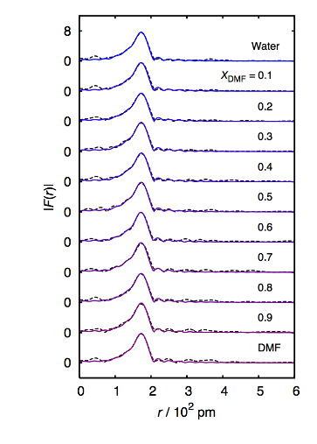
The values show that the solvated structure of Mn(II) ion in water-DMF mixtures is six-coordinate and the Mn-O distance is 217(2) pm on average at all mole fractions.

Acknowledgement
This research was supported by New Energy and Industrial Technology Development Organization (NEDO) and Open Advanced Research Facilities Initiative.
Fig. 2 The radial structure functions |F(r)| for Mn(II) ion in water-DMF solvents, phase shift uncorrected. The dashed lines are obtained experimentally, and the solid lines are calculated.

References
[1] K. Ozutsumi, M. Koide, H. Suzuki, and S. Ishiguro, J. Phys. Chem., 1993, 97, 500.
[2] Y. Inada, K. Sugimoto, K. Ozutsumi, and S. Funahashi, Inorg. Chem., 1994, 33, 1875.
[3] Y. Inada, H. Hayashi, K. Sugimoto, and S. Funahashi, J. Phys. Chem. A, 1999, 103, 1401.

