Solvation Structure of Manganese(II) Ion in Water-N,N-Dimethylformamide and Water-1,1,3,3-Tetramethylurea Mixed Solvents
著者名：
12ポイント－中央
（太文字）
原則１ページ
フォントはTimes New Roman
12ポイントで１行 あける
表題：
12ポイント－中央
（太文字）

Misaki Katayama¹, Daisuke Tomita², Yuki Kajiya², Kenta Uoya²,
and Kazuhiko Ozutsumi²
- Research Organization of Science & Engineering, Ritsumeikan University, 1-1-1 Noji-Higashi, Kusatsu 525-8577, Japan
- Department of Applied Chemistry, Faculty of Life Sciences, Ritsumeikan University, 1-1-1 Noji-Higashi, Kusatsu 525-8577, Japan
所属：12ポイント－（斜体）
12ポイントで１行 あける
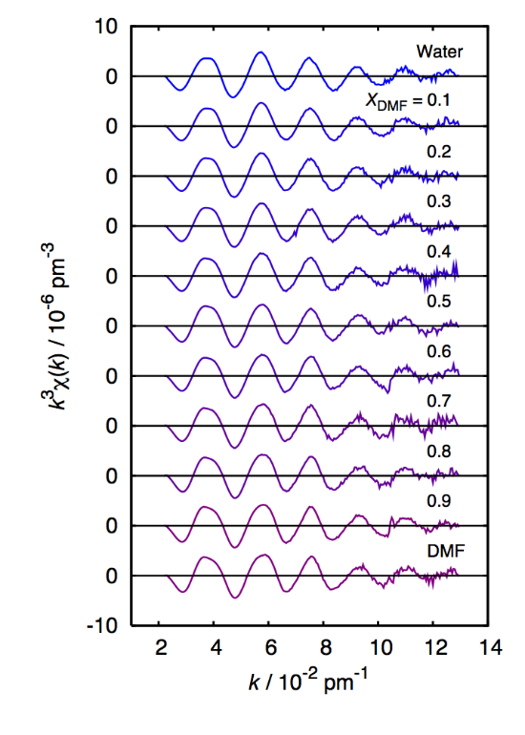

In two component solvent mixtures, an ion is solvated with two different kinds of solvent molecules. The solvent composition in the first coordination sphere of the ion may usually not be the same as that in the bulk. Such preferential solvation phenomena affect t
本文：A4・縦長・横書き
カメラレディー方式
10ポイント

………………..

Manganese(II) perchlorate hydrate was prepared by dissolving the manganese carbonate in dilute perchloric acid and then recrystallized from water. Manganese(II) perchlorate ……………..

The extracted EXAFS oscillations of Mn(II) in the water-DMF solvents are shown in Fig. 1. The phase and amplitude of each curve are similar, although the shape at k = 3 to 6 ….

Fig. 1 The extracted EXAFS oscillations in the form of k³χ(k) for Mn(II) ion in water-DMF solvents.

The. values show that the solvated structure of Mn(II) ion in water-DMF mixtures is six-coordinate and the Mn-O distance is 217(2) pm on average at all mole fractions.

References
[1] K. Ozutsumi, M. Koide, H. Suzuki, and S. Ishiguro, J. Phys. Chem., 1993, 97, 500.
[2] Y. Inada, K. Sugimoto, K. Ozutsumi, and S. Funahashi, Inorg. Chem., 1994, 33, 1875.
[3] Y. Inada, H. Hayashi, K. Sugimoto, and S. Funahashi, J. Phys. Chem. A, 1999, 103, 1401.

