**Abstract Template for the 14th Japan-Korea Conference on Ferroelectrics**

**Akitoshi Koreeda1,* and Chan-Ho Yang2**

1 Dept. Phys. Sci., Ritsumeikan Univ.

2 Dept. Phys., KAIST

* E-mail address of the corresponding author: ABC@XYZ.ac.jp

One-page abstract written in English should be submitted from the submission page of the conference website. The acceptable file format is Adobe PDF (*.pdf) only. Authors must prepare their abstract for direct reproduction in the abstract book; the abstract text will appear precisely as the author prepared. Abstracts must be entered into the provide Word docx form and be prepared according to the following rules:

1. The size of the paper will be A4 (210×297 mm). The top, bottom, left, and right margins of the printed area should be 25 mm. The line spacing should be 18 pt.

(2) The text should be written in Times New Roman 12pt, except the title.

(3) The title should be written in bold Times New Roman 14pt. It should be placed at the center of each line.

(4) After 1 line spacing, the author names should be written in bold Times New Roman

12pt, at the center of the line. The author who will present your result should be underlined, and the corresponding author should be marked with “*”.

(5) Without any spacing, the affiliation should be written in sequence.

(6) After 1 line spacing, “*E-mail of the corresponding author” should be given.

(7) After 2 lines spacing, you can start to write the main content of the abstract.

(8) A couple of figures can be inserted in the abstract, but grayscale images may not　reproduce well.

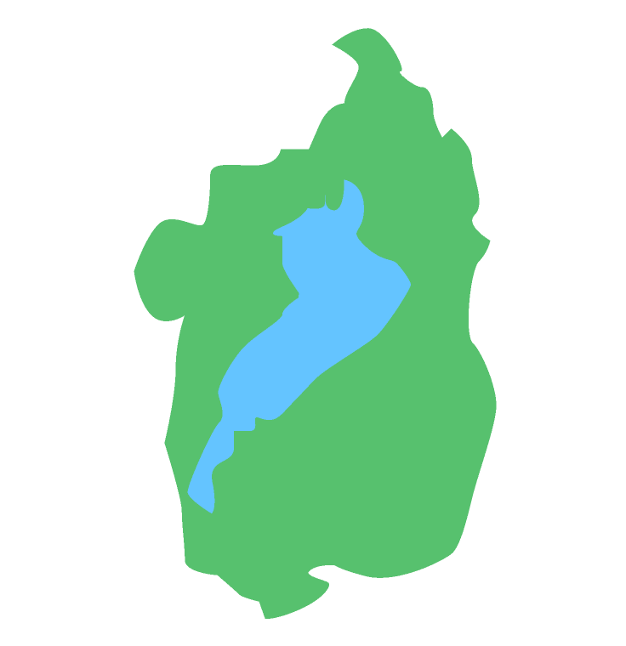

Figure 1: Shiga Prefecture. Lake Biwa occupies about 1/6 of the entire area [1].

(9) You can include figures and tables. However, please keep in mind that the abstract page limitation is 1 page.

The filename of the abstract file should be “Abstract_your first name_last name_O” or “Abstract_your first name_last name_P”, depending on the preference of your presentation style. (O: oral presentation including oral or poster; P: poster).

References

[1] https://en.wikipedia.org/wiki/Shiga_Prefecture