The B4 Members of MINiDeL Lab.

Photos:taken on Jan.13, 2006, New Year’s Welcome Party (‘Sukiyaki-nabe’ Party)
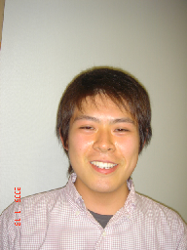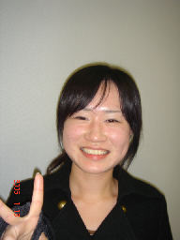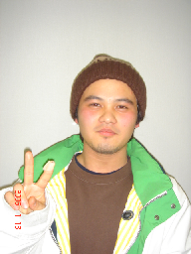
辻 Tsuji-kun 山口 Yamaguchi-san 佐々 Sasa-kun
Looks like Begin’s Singer?

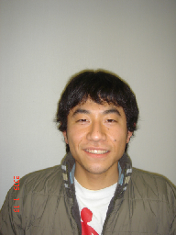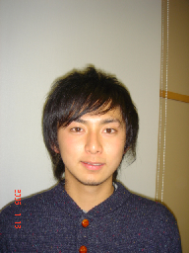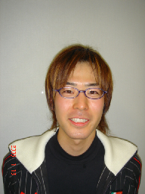
万田 Manta-kun 古市 Furuichi-kun 稲葉 Inaba-kun
Noh-player ? ‘ Ikemen ’ No.1?

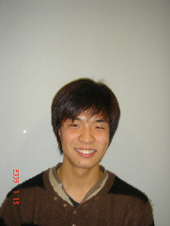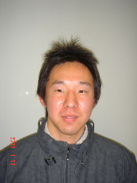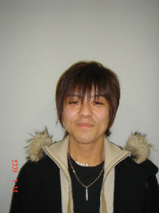
千川 Senkawa-kun 高島 Takashima-kun 大嶽 Ohtake-kun
Photo:taken on Jan.9, 2007, New Year’s Party (‘Hokkaido-Ishikari-Nabe’ Party)
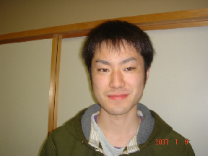
中澤 Nakazawa-kun

